**Lab Exercises**

Class: 软件1801 Name: 陈春雨 StuID:___201816040129____

Date: 2019.12.06 Score:

**Lab Exercise 1 — Account Hierarchy**

**I Lab Objectives**

In this lab, you will practice:

1. Using inheritance to create an account hierarchy that includes an Account class, a SavingsAccount class and a CheckingAccount class.
2. Using private data members to limit access to data members.
3. Redefining base-class member functions in a derived class.

**II Description of the Problem(译文见教材P387 11.10)**

Create an inheritance hierarchy that a bank might use to represent customers’ bank accounts. All customers at this bank can deposit (i.e., credit) money into their accounts and withdraw (i.e., debit) money from their accounts. More specific types of accounts also exist. Savings accounts, for instance, earn interest on the money they hold. Checking accounts, on the other hand, charge a fee per transaction (i.e., credit or debit).

Create an inheritance hierarchy containing base class Account and derived classes SavingsAccount and CheckingAccount that inherit from class Account. Base class Account should include one data member of type double to represent the account balance. The class should provide a constructor that receives an initial balance and uses it to initialize the data member. The constructor should validate the initial balance to ensure that it is greater than or equal to 0.0. If not, the balance should be set to 0.0 and the constructor should display an error message, indicating that the initial balance was invalid. The class should provide three member functions. Member function credit should add an amount to the current balance. Member function debit should withdraw money from the Account and ensure that the debit amount does not exceed the Account’s balance. If it does, the balance should be left unchanged and the function should print the message "Debit amount exceeded account balance." Member function getBalance should return the current balance.

Derived class SavingsAccount should inherit the functionality of an Account, but also include a data member of type double indicating the interest rate (percentage) assigned to the Account. SavingsAccount’s constructor should receive the initial balance, as well as an initial value for the SavingsAccount’s interest rate. SavingsAccount should provide a public member function calculateInterest that returns a double indicating the amount of interest earned by an account. Member function calculateInterest should determine this amount by multiplying the interest rate by the account balance. [Note: SavingsAccount should inherit member functions credit and debit as is without redefining them.]

Derived class CheckingAccount should inherit from base class Account and include an additional data member of type double that represents the fee charged per transaction. CheckingAccount’s constructor should receive the initial balance, as well as a parameter indicating a fee amount. Class CheckingAccount should redefine member functions credit and debit so that they subtract the fee from the account balance whenever either transaction is performed successfully. CheckingAccount’s versions of these functions should invoke the base-class Account version to perform the updates to an account balance. CheckingAccount’s debit function should charge a fee only if money is actually withdrawn (i.e., the debit amount does not exceed the account balance). [*Hint*: Define Account’s debit function so that it returns a bool indicating whether money was withdrawn. Then use the return value to determine whether a fee should be charged.]

After defining the classes in this hierarchy, write a program that creates objects of each class and tests their member functions. Add interest to the SavingsAccount object by first invoking its calculateInterest function, then passing the returned interest amount to the object’s credit function.

**III Sample Output**

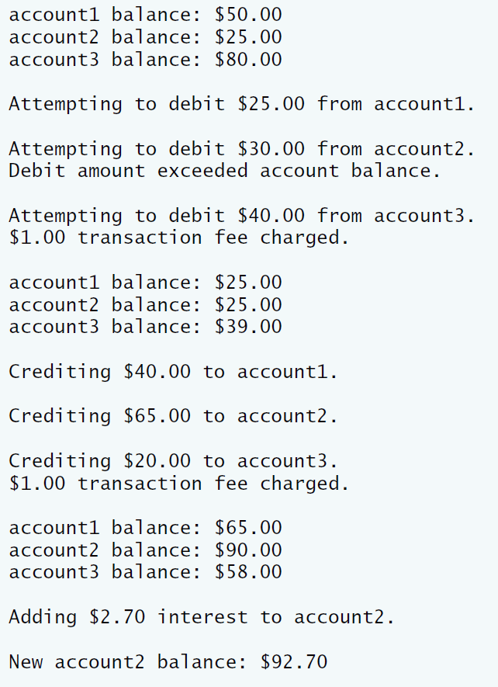

**IV Problem-Solving Tips**

1. Each derived class constructor, SavingsAccount and CheckingAccount, should call the Account constructor explicitly.
2. Do not use the debit member function inside the chargeFee member function, because the debit member function would then call the chargeFee member function, leading to infinite recursion. Instead use the inherited *get* and *set* functions for the account balance.

**V Your Solution**

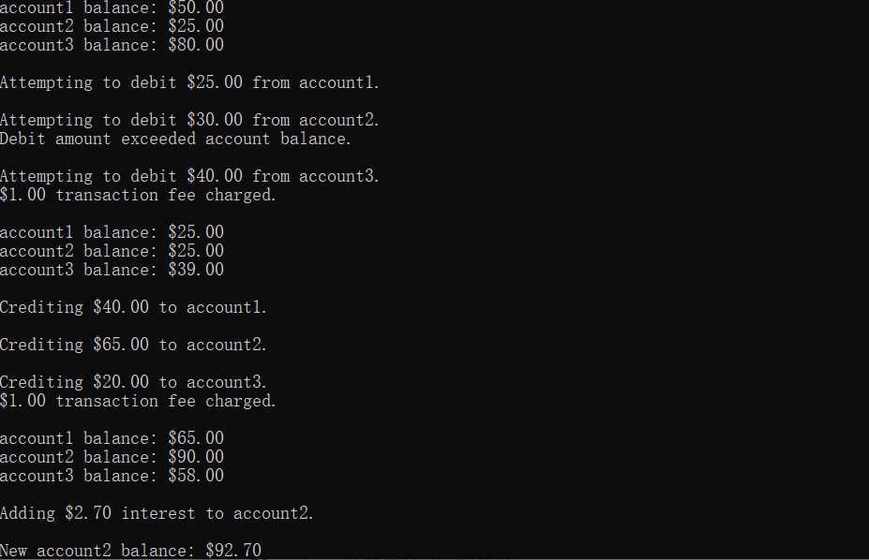

// Lab 1: Account.h

// Definition of Account class.

#ifndef ACCOUNT_H

#define ACCOUNT_H

class Account

{

public:

Account( double ); // constructor initializes balance//初始化余额

void credit( double ); // add an amount to the account balance//向当前表示余额的数据成员加钱

bool debit( double ); // subtract an amount from the account balance//从账户中取钱

void setBalance( double ); // sets the account balance//余额

double getBalance(); // return the account balance//余额

private:

double balance; // data member that stores the balance//账户余额

}; // end class Account

#endif

// Lab 1: Account.cpp

// Member-function definitions for class Account.

#include <iostream>

using namespace std;

#include "Account.h" // include definition of class Account

// Account constructor initializes data member balance

Account::Account( double initialBalance )

{

// if initialBalance is greater than or equal to 0.0, set this value

// as the balance of the Account

if ( initialBalance >= 0.0 )

balance = initialBalance;

else // otherwise, output message and set balance to 0.0

{

cout << "Error: Initial balance cannot be negative." << endl;

balance = 0.0;

} // end if...else

} // end Account constructor

// credit (add) an amount to the account balance

void Account::credit( double amount )

{

balance = balance + amount; // add amount to balance

} // end function credit

// debit (subtract) an amount from the account balance

// return bool indicating whether money was debited

bool Account::debit( double amount )

{

if ( amount > balance ) // debit amount exceeds balance

{

cout << "Debit amount exceeded account balance." << endl;

return false;

} // end if

else // debit amount does not exceed balance

{

balance = balance - amount;

return true;

} // end else

} // end function debit

// set the account balance

void Account::setBalance( double newBalance )

{

balance = newBalance;

} // end function setBalance

// return the account balance

double Account::getBalance()

{

return balance;

} // end function getBalance

// Lab 1: CheckingAccount.h

// Definition of CheckingAccount class.

#ifndef CHECKING_H

#define CHECKING_H

#include "Account.h"

/* Write a directive to include the Account header file */

/* Write a line to have class CheckingAccount inherit publicly from Account */

class CheckingAccount:public Account

{

public:

// constructor initializes balance and transaction fee

CheckingAccount(double,double);

/* Declare a two-argument constructor for CheckingAccount */

void credit(double=0);

/* Redeclare member function credit, which will be redefined */

bool debit(double);

void chargeFee();

/* Redeclare member function debit, which will be redefined */

private:

double transactionFee;

/* Declare data member transactionFee */

// utility function to charge fee

//double chargeFee;

/* Declare member function chargeFee */

}; // end class CheckingAccount

#endif

// Lab 1: CheckingAccount.cpp

// Member-function definitions for class CheckingAccount.

#include <iostream>

using namespace std;

#include "CheckingAccount.h" // CheckingAccount class definition

// constructor initializes balance and transaction fee

CheckingAccount::CheckingAccount(double a,double b)

:Account(a)

{

transactionFee=b;

//a=chargeFee();

}

/* Write the CheckingAccount constructor to call the Account constructor

and validate and set the transaction fee value */

// credit (add) an amount to the account balance and charge fee

/* Write the credit member function to call Account's credit function

and then charge a fee */

void CheckingAccount::credit(double b)

{

Account::credit(b);

chargeFee();

//getBalance()=getBalance()+b;

}

// debit (subtract) an amount from the account balance and charge fee

/* Write the debit member function to call Account's debit function

and then charge a fee if it returned true*/

bool CheckingAccount::debit(double amount)

{

Account::debit(amount);

chargeFee();

}

// subtract transaction fee

/* Write the chargeFee member function to subtract transactionFee

from the current balance and display a message */

void CheckingAccount::chargeFee()

{

setBalance(getBalance()-transactionFee );

cout<<"$"<<transactionFee<<" "<<"transaction fee charged."<<endl;

}

// Lab 1: SavingsAccount.h

// Definition of SavingsAccount class.

#ifndef SAVINGS_H

#define SAVINGS_H

#include "Account.h"

/* Write a directive to include the Account header file */

/* Write a line to have class SavingsAccount inherit publicly from Account */

class SavingsAccount:public Account

{

public:

// constructor initializes balance and interest rate

SavingsAccount(double,double);

/* Declare a two-parameter constructor for SavingsAccount */

double calculateInterest();

/* Declare member function calculateInterest */

private:

double interestRate;

/* Declare data member interestRate */

}; // end class SavingsAccount

#endif

// Lab 1: SavingsAccount.cpp

// Member-function definitions for class SavingsAccount.

#include "SavingsAccount.h" // SavingsAccount class definition

// constructor initializes balance and interest rate

SavingsAccount::SavingsAccount(double a,double b)

:Account(a)

{

interestRate=b;

}

/* Write the SavingsAccount constructor to call the Account constructor

and validate and set the interest rate value */

// return the amount of interest earned

double SavingsAccount::calculateInterest()

{

return (getBalance()*interestRate);

}

/* Write the calculateInterest member function to return the

interest based on the current balance and interest rate */

// Lab 1: bankAccounts.cpp

// Test program for Account hierarchy.

#include <iostream>

#include <iomanip>

using namespace std;

#include "Account.h" // Account class definition

#include "SavingsAccount.h" // SavingsAccount class definition

#include "CheckingAccount.h" // CheckingAccount class definition

int main()

{

Account account1( 50.0 ); // create Account object

SavingsAccount account2( 25.0, .03 ); // create SavingsAccount object

CheckingAccount account3( 80.0, 1.0 ); // create CheckingAccount object

cout << fixed << setprecision( 2 );

// display initial balance of each object

cout << "account1 balance: $" << account1.getBalance() << endl;

cout << "account2 balance: $" << account2.getBalance() << endl;

cout << "account3 balance: $" << account3.getBalance() << endl;

cout << "\nAttempting to debit $25.00 from account1." << endl;

account1.debit( 25.0 ); // try to debit $25.00 from account1

cout << "\nAttempting to debit $30.00 from account2." << endl;

account2.debit( 30.0 ); // try to debit $30.00 from account2

cout << "\nAttempting to debit $40.00 from account3." << endl;

account3.debit( 40.0 ); // try to debit $40.00 from account3

// display balances

cout << "\naccount1 balance: $" << account1.getBalance() << endl;

cout << "account2 balance: $" << account2.getBalance() << endl;

cout << "account3 balance: $" << account3.getBalance() << endl;

cout << "\nCrediting $40.00 to account1." << endl;

account1.credit( 40.0 ); // credit $40.00 to account1

cout << "\nCrediting $65.00 to account2." << endl;

account2.credit( 65.0 ); // credit $65.00 to account2

cout << "\nCrediting $20.00 to account3." << endl;

account3.credit( 20.0 ); // credit $20.00 to account3

// display balances

cout << "\naccount1 balance: $" << account1.getBalance() << endl;

cout << "account2 balance: $" << account2.getBalance() << endl;

cout << "account3 balance: $" << account3.getBalance() << endl;

// add interest to SavingsAccount object account2

/* Declare a variable interestEarned and assign it the interest

account2 should earn */

double interestEarned;

interestEarned=account2.calculateInterest();

cout << "\nAdding $" << interestEarned << " interest to account2."

<< endl;

/* Write a statement to credit the interest to account2's balance */

account2.credit(interestEarned);

cout << "\nNew account2 balance: $" << account2.getBalance() << endl;

} // end main

**Lab Exercise 2 — Composition**

**I Lab Objectives**

In this lab, you will practice:

1. Using composition to incorporate one class’s members into another class.

The follow-up question and activity also will give you practice:

1. Comparing inheritance and composition.

**II Description of the Problem (译文见P386 11.3)**

Many programs written with inheritance could be written with composition instead, and vice versa. Rewrite class BasePlusCommissionEmployee of the CommissionEmploy ee–BasePlusCommissionEmployee hierarchy to use composition rather than inheritance.

**III Sample Output**

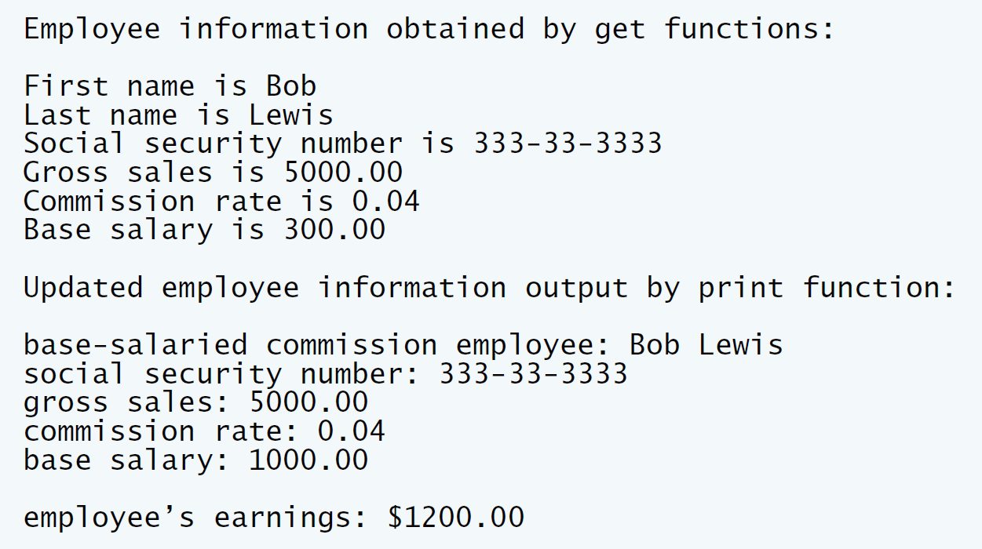

**IV Problem-Solving Tips**

1. To implement BasePlusCommissionEmployee using composition, include a ComissionEmployee object as a data member in the BasePlusCommission Employee class.
2. To access a member of CommissionEmployee inside a member function of BasePlusCommissionEmployee, it must be preceded by the name of the CommissionEmployee object and the dot operator.
3. Most of BasePlusCommissionEmployee’s member functions will be implemented by simply calling the same member function from the CommissionEmployee object; this is known as “delegation.”

**V Your Solution**

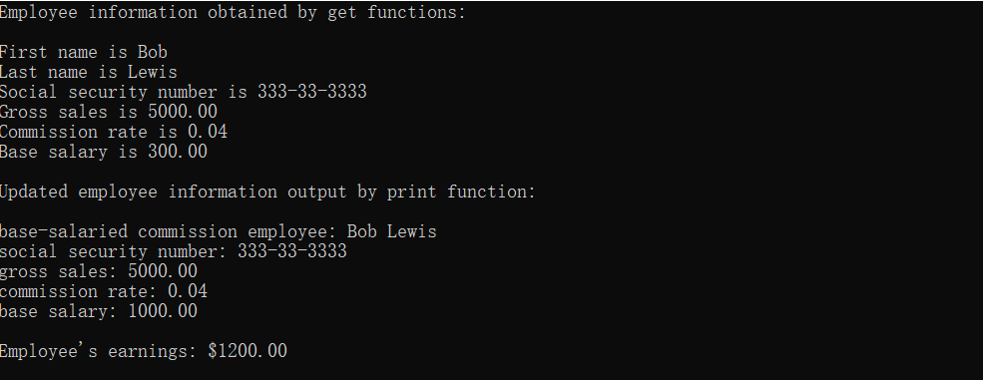

// Lab 2: CommissionEmployee.h

// CommissionEmployee class definition represents a commission employee.

#ifndef COMMISSION_H

#define COMMISSION_H

#include <string> // C++ standard string class

using namespace std;

class CommissionEmployee

{

public:

CommissionEmployee( const string &, const string &, const string &,

double = 0.0, double = 0.0 );

void setFirstName( const string & ); // set first name

string getFirstName() const; // return first name

void setLastName( const string & ); // set last name

string getLastName() const; // return last name

void setSocialSecurityNumber( const string & ); // set SSN

string getSocialSecurityNumber() const; // return SSN

void setGrossSales( double ); // set gross sales amount

double getGrossSales() const; // return gross sales amount

void setCommissionRate( double ); // set commission rate (percentage)

double getCommissionRate() const; // return commission rate

double earnings() const; // calculate earnings

void print() const; // print CommissionEmployee object

private:

string firstName;

string lastName;

string socialSecurityNumber;

double grossSales; // gross weekly sales

double commissionRate; // commission percentage

}; // end class CommissionEmployee

#endif

// Lab 2: CommissionEmployee.cpp

// Class CommissionEmployee member-function definitions.

#include <iostream>

using namespace std;

#include "CommissionEmployee.h" // CommissionEmployee class definition

// constructor

CommissionEmployee::CommissionEmployee(

const string &first, const string &last, const string &ssn,

double sales, double rate )

{

firstName = first; // should validate

lastName = last; // should validate

socialSecurityNumber = ssn; // should validate

setGrossSales( sales ); // validate and store gross sales

setCommissionRate( rate ); // validate and store commission rate

} // end CommissionEmployee constructor

// set first name

void CommissionEmployee::setFirstName( const string &first )

{

firstName = first; // should validate

} // end function setFirstName

// return first name

string CommissionEmployee::getFirstName() const

{

return firstName;

} // end function getFirstName

// set last name

void CommissionEmployee::setLastName( const string &last )

{

lastName = last; // should validate

} // end function setLastName

// return last name

string CommissionEmployee::getLastName() const

{

return lastName;

} // end function getLastName

// set social security number

void CommissionEmployee::setSocialSecurityNumber( const string &ssn )

{

socialSecurityNumber = ssn; // should validate

} // end function setSocialSecurityNumber

// return social security number

string CommissionEmployee::getSocialSecurityNumber() const

{

return socialSecurityNumber;

} // end function getSocialSecurityNumber

// set gross sales amount

void CommissionEmployee::setGrossSales( double sales )

{

grossSales = ( sales < 0.0 ) ? 0.0 : sales;

} // end function setGrossSales

// return gross sales amount

double CommissionEmployee::getGrossSales() const

{

return grossSales;

} // end function getGrossSales

// set commission rate

void CommissionEmployee::setCommissionRate( double rate )

{

commissionRate = ( rate > 0.0 && rate < 1.0 ) ? rate : 0.0;

} // end function setCommissionRate

// return commission rate

double CommissionEmployee::getCommissionRate() const

{

return commissionRate;

} // end function getCommissionRate

// calculate earnings

double CommissionEmployee::earnings() const

{

return commissionRate * grossSales;

} // end function earnings

// print CommissionEmployee object

void CommissionEmployee::print() const

{

cout << "commission employee: " << firstName << ' ' << lastName

<< "\nsocial security number: " << socialSecurityNumber

<< "\ngross sales: " << grossSales

<< "\ncommission rate: " << commissionRate;

} // end function print

// Lab 2: BasePlusCommissionEmployee.h

// BasePlusCommissionEmployee class using composition.

#ifndef BASEPLUS_H

#define BASEPLUS_H

#include <string> // C++ standard string class

using namespace std;

#include "CommissionEmployee.h" // CommissionEmployee class definition

class BasePlusCommissionEmployee

{

public:

BasePlusCommissionEmployee( const string &, const string &,

const string &, double = 0.0, double = 0.0, double = 0.0 );

void setFirstName( const string & ); // set first name

string getFirstName() const; // return first name

void setLastName( const string & ); // set last name

string getLastName() const; // return last name

void setSocialSecurityNumber( const string & ); // set SSN

string getSocialSecurityNumber() const; // return SSN

void setGrossSales( double ); // set gross sales amount

double getGrossSales() const; // return gross sales amount

void setCommissionRate( double ); // set commission rate

double getCommissionRate() const; // return commission rate

void setBaseSalary( double ); // set base salary

double getBaseSalary() const; // return base salary

double earnings() const; // calculate earnings

void print() const; // print BasePlusCommissionEmployee object

private:

double baseSalary; // base salary

class CommissionEmployee c;

/* Write a declaration for a CommissionEmployee

data member */

}; // end class BasePlusCommissionEmployee

#endif

// Lab 2: BasePlusCommissionEmployee.cpp

// Member-function definitions of class BasePlusCommissionEmployee

// using composition.

#include <iostream>

using namespace std;

// BasePlusCommissionEmployee class definition

#include "BasePlusCommissionEmployee.h"

// constructor

BasePlusCommissionEmployee::BasePlusCommissionEmployee(

const string &first, const string &last, const string &ssn,

double sales, double rate, double salary )

// initialize composed object

: c(first,last,ssn,sales,rate) /* Initialize the commissionEmployee data member,

pass (first, last, ssn, sales, rate) to its constructor */

{

setBaseSalary( salary ); // validate and store base salary

} // end BasePlusCommissionEmployee constructor

// set commission employee's first name

void BasePlusCommissionEmployee::setFirstName( const string &first )

{

c.setFirstName(first);

/* Call commissionEmployee's setFirstName function */

} // end function setFirstName

// return commission employee's first name

string BasePlusCommissionEmployee::getFirstName() const

{

return c.getFirstName();

/* Call commissionEmployee's getFirstName function */

} // end function getFirstName

// set commission employee's last name

void BasePlusCommissionEmployee::setLastName( const string &last )

{

c.setLastName(last);

/* Call commissionEmployee's setLastName function */

} // end function setLastName

// return commission employee's last name

string BasePlusCommissionEmployee::getLastName() const

{

return c.getLastName();

/* Call commissionEmployee's getLastName function */

} // end function getLastName

// set commission employee's social security number

void BasePlusCommissionEmployee::setSocialSecurityNumber(

const string &ssn )

{

c.setSocialSecurityNumber(ssn);

/* Call commissionEmployee's setSocialSecurity function */

} // end function setSocialSecurityNumber

// return commission employee's social security number

string BasePlusCommissionEmployee::getSocialSecurityNumber() const

{

return c.getSocialSecurityNumber();

/* Call commissionEmployee's getSocialSecurity function */

} // end function getSocialSecurityNumber

// set commission employee's gross sales amount

void BasePlusCommissionEmployee::setGrossSales( double sales )

{

c.setGrossSales(sales);

/* Call commissionEmployee's setGrossSales function */

} // end function setGrossSales

// return commission employee's gross sales amount

double BasePlusCommissionEmployee::getGrossSales() const

{

return c.getGrossSales();

/* Call commissionEmployee's getGrossSales function */

} // end function getGrossSales

// set commission employee's commission rate

void BasePlusCommissionEmployee::setCommissionRate( double rate )

{

c.setCommissionRate(rate);

/* Call commissionEmployee's setCommissionRate function */

} // end function setCommissionRate

// return commission employee's commission rate

double BasePlusCommissionEmployee::getCommissionRate() const

{

return c.getCommissionRate();

/* Call commissionEmployee's getCommissionRate function */

} // end function getCommissionRate

// set base salary

void BasePlusCommissionEmployee::setBaseSalary( double salary )

{

baseSalary = ( salary < 0.0 ) ? 0.0 : salary;

} // end function setBaseSalary

// return base salary

double BasePlusCommissionEmployee::getBaseSalary() const

{

return baseSalary;

} // end function getBaseSalary

// calculate earnings

double BasePlusCommissionEmployee::earnings() const

{

return getBaseSalary() +c.earnings()

/* Call commissionEmployee's earnings function */;

} // end function earnings

// print BasePlusCommissionEmployee object

void BasePlusCommissionEmployee::print() const

{

cout << "base-salaried ";

c.print();

// invoke composed CommissionEmployee object's print function

/* Call commissionEmployee's print function */

cout << "\nbase salary: " << getBaseSalary();

} // end function print

// Lab 2: composition.cpp

// Testing class BasePlusCommissionEmployee.

#include <iostream>

#include <iomanip>

using namespace std;

// BasePlusCommissionEmployee class definition

#include "BasePlusCommissionEmployee.h"

int main()

{

// instantiate BasePlusCommissionEmployee object

BasePlusCommissionEmployee

employee( "Bob", "Lewis", "333-33-3333", 5000, .04, 300 );

// set floating-point output formatting

cout << fixed << setprecision( 2 );

// get commission employee data

cout << "Employee information obtained by get functions: \n"

<< "\nFirst name is " << employee.getFirstName()

<< "\nLast name is " << employee.getLastName()

<< "\nSocial security number is "

<< employee.getSocialSecurityNumber()

<< "\nGross sales is " << employee.getGrossSales()

<< "\nCommission rate is " << employee.getCommissionRate()

<< "\nBase salary is " << employee.getBaseSalary() << endl;

employee.setBaseSalary( 1000 ); // set base salary

cout << "\nUpdated employee information output by print function: \n"

<< endl;

employee.print(); // display the new employee information

// display the employee's earnings

cout << "\n\nEmployee's earnings: $" << employee.earnings() << endl;

} // end main

**VI Follow-Up Questions and Activities**

1. Assess the relative merits of the two approaches for designing classes Commission-Employee and BasePlusCommissionEmployee, as well as for object-oriented programs in general. Which approach is more natural? Why?

　 组合更自然，下面为组合的优点：

①当前对象只能通过所包含的那个对象去调用其方法，所以所包含的对象的内部

细节对当前对象是不可见的。

　②当前对象与包含的对象是一个低耦合关系，如果修改包含对象的类中代码不需要修改当前对象类的代码。

　③当前对象可以在运行时动态的绑定所包含的对象。

由此可见，组合承更具灵活性和稳定性。